RAJIV GANDHI MEMORIAL COLLEG, LENGTISIGA
Working days/classes /Induction day-August, 2018
Date | Description | Working Days (WD) | Holidays (H)
1 | Induction Day/ WD | 01 | 00
2-4 | WD/Class | 03 | 00
5 | Sunday(H) | 00 | 01
6-11 | WD/Class | 06 | 00
12 | Sunday(H) | 00 | 01
13-14 | WD/Class | 02 | 00
15 | Independence Day(H) | 00 | 01
16 | WD/Class | 01 | 00
17 | Death of former P.M. A.B. Bajpayee (H) | 00 | 01
18 | WD/Class | 01 | 00
19 | Sunday(H) | 00 | 01
20-21 | WD/Class | 02 | 00
22-23 | Eid-uz-Zoha (H) | 00 | 02
24-25 | WD/Class | 02 | 00
26 | Sunday(H) | 00 | 01
27-30 | WD/Class | 04 | 00
31 | Tithi of Sri Sri Madhabdeva (H) | 00 | 01
WD= 22 (H) = 09
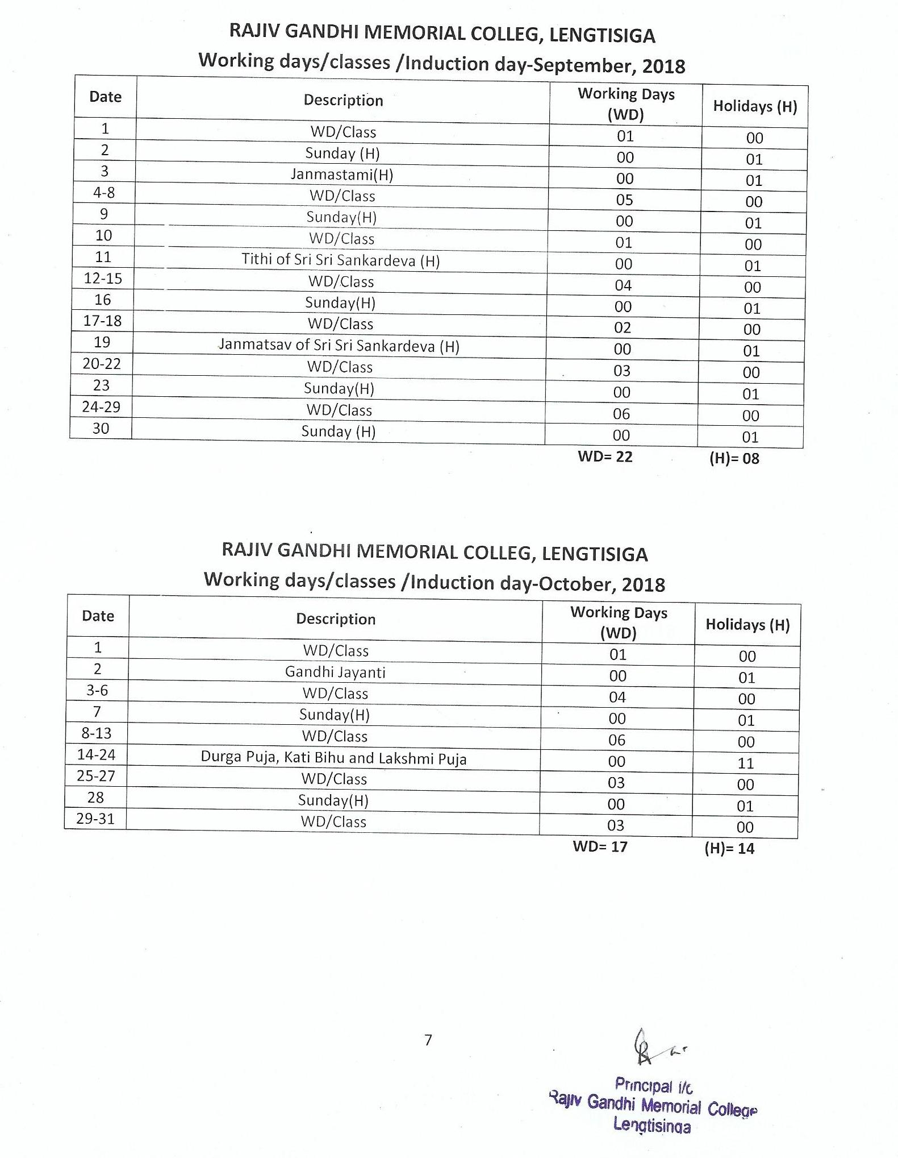
RAJIV GANDHI MEMORIAL COLLEG, LENGTISIGA
Working days/classes /Induction day-November, 2018

Date | Description | Working Days (WD) | Holidays (H)
1-3 | WD/Class | 03 | 00
4 | Sunday(H) | 00 | 01
5 | WD/Class | 01 | 00
6-7 | Kali Puja & Diwali (H) | 00 | 02
8-10 | WD/Class | 03 | 00
11 | Sunday (H) | 00 | 01
12 | WD/Class | 01 | 00
13 | Chhat Puja | 00 | 01
14-17 | WD/Class | 04 | 00
18 | Sunday (H) | 00 | 01
19-22 | WD/Class | 04 | 00
23-25 | Bithday of Guru Nanak, Lachit Diwas & Sunday (H) | 00 | 03
26-30 | WD/Class | 05 | 00
WD= 21 (H)= 09
Odd Semester Examination to be held in the months of November and December.

RAJIV GANDHI MEMORIAL COLLEG, LENGTISIGA
Working days/classes /Induction day-December, 2018
Date | Description | Working Days (WD) | Holidays (H)
1 | WD/Class | 01 | 00
2 | Sunday/Axom Diwas (H) | 00 | 01
3-8 | WD/Class | 06 | 00
9 | Sunday(H) | 00 | 01
10-15 | WD/Class | 06 | 00
16 | Sunday(H) | 00 | 01
17-22 | WD/Class | 06 | 00
23 | Sunday(H) | 00 | 01
24 | WD/Class | 01 | 00
25 | Chrirstmas Day | 00 | 01
26-31 | Semester Break (H) | 00 | 06
WD= 20 (H)= 11

RAJIV GANDHI MEMORIAL COLLEG, LENGTISIGA
Working days/classes /Induction day-January, 2019
Date | Description | Working Days (WD) | Holidays (H)
1-5 | WD/Class | 05 | 00
6 | Sunday(H) | 00 | 01
7-20 | Winter Vacation & Magh Bihu (H) | 00 | 14
21-25 | WD/Class | 05 | 00
26 | Republic Day | 00 | 01
27 | Sunday(H) | 00 | 01
28-31 | WD/Class | 04 | 00
WD= 14 (H)= 17

RAJIV GANDHI MEMORIAL COLLEG, LENGTISIGA
Working days/classes /Induction day-February, 2019
Date | Description | Working Days (WD) | Holidays (H)
1-2 | WD/Class | 02 | 00
3 | Sunday(H) | 00 | 01
4-9 | WD/Class | 06 | 00
10 | Saraswati Puja/Sunday (H) | 00 | 01
11-16 | WD/Class | 06 | 00
17 | Sunday(H) | 00 | 01
18-23 | WD/Class | 06 | 00
24 | Sunday(H) | 00 | 01
25-28 | WD/Class | 04 | 00
WD= 24 (H)= 04

RAJIV GANDHI MEMORIAL COLLEG, LENGTISIGA
Working days/classes /Induction day-March, 2019
Date | Description | Working Days (WD) | Holidays (H)
1-2 | WD/Class | 02 | 00
3 | Sunday(H) | 00 | 01
4 | Shivaratri | 00 | 01
5-9 | WD/Class | 05 | 00
10 | Sunday(H) | 00 | 01
11-16 | WD/Class | 06 | 00
17 | Sunday(H) | 00 | 01
18-20 | WD/Class | 03 | 00
21-22 | Doul Yatra (H) | 00 | 02
23 | WD/Class | 01 | 00
24 | Sunday(H) | 00 | 01
25-30 | WD/Class | 06 | 00
31 | Sunday (H) | 00 | 01
WD= 23 (H)= 08

RAJIV GANDHI MEMORIAL COLLEG, LENGTISIGA
Working days/classes /Induction day-April, 2019
Date | Description | Working Days (WD) | Holidays (H)
1-6 | WD/Class | 06 | 00
7 | Sunday(H) | 00 | 01
8-13 | WD/Class | 06 | 00
14-16 | Sunday cum Bohag Bihu (H) | 00 | 03
17-18 | WD/Class | 02 | 00
19 | Good Friday(H) | 00 | 01
20 | WD/Class | 01 | 00
21 | Sunday(H) | 00 | 01
22 | WD/Class | 01 | 00
23 | Holiday for Election | 00 | 01
24-27 | WD/Class | 04 | 00
28 | Sunday(H) | 00 | 01
29-30 | WD/Class | 02 | 00
WD= 22 (H)= 08

RAJIV GANDHI MEMORIAL COLLEG, LENGTISIGA
Working days/classes /Induction day-May, 2019
Date | Description | Working Days (WD) | Holidays (H)
1 | May Day (H) | 00 | 01
2-4 | WD/Class | 03 | 00
5 | Sunday(H) | 00 | 01
6-11 | WD/Class | 06 | 00
12 | Sunday(H) | 00 | 01
13-17 | WD/Class | 05 | 00
18 | Buddha purnima (H) | 00 | 01
19 | Sunday(H) | 00 | 01
20-25 | WD/Class | 06 | 00
26 | Sunday(H) | 00 | 01
27-31 | WD/Class | 05 | 00
WD= 25 (H)= 06
Even Semester Final Examination to be held in the months of May and June.

RAJIV GANDHI MEMORIAL COLLEG, LENGTISIGA
Working days/classes /Induction day-June, 2019
Date | Description | Working Days (WD) | Holidays (H)
1 | WD/Class | 01 | 00
2 | Sunday(H) | 00 | 01
3-4 | WD/Class | 02 | 00
5-6 | Idul-Fitre | 00 | 02
7-8 | WD/Class | 02 | 00
9 | Sunday(H) | 00 | 01
10-15 | WD/Class | 06 | 00
16 | Sunday(H) | 00 | 01
17-22 | WD/Class | 06 | 00
23 | Sunday(H) | 00 | 01
24-29 | WD/Class | 06 | 00
30 | Sunday(H) | 00 | 01
WD= 23 (H)= 07
Note:
- Summer Vacation from-01-07-2019 to 31-07-2019
- Subject to revision as per G. U. academic calendar 2018-2019
- Holidays mention in the calendar may be changed subject to Govt. and University notifications.
- Dates of B. A. Semester Examinations will be notified by G.U.
- Total Working Days= 233
- Total Holidays= 101
** WD stands for Working Days.* (H) for Holidays.

