RAJIV GANDHI MEMORIAL COLLEG, LENGTISIGA
Working days/classes /Induction day-August, 2017
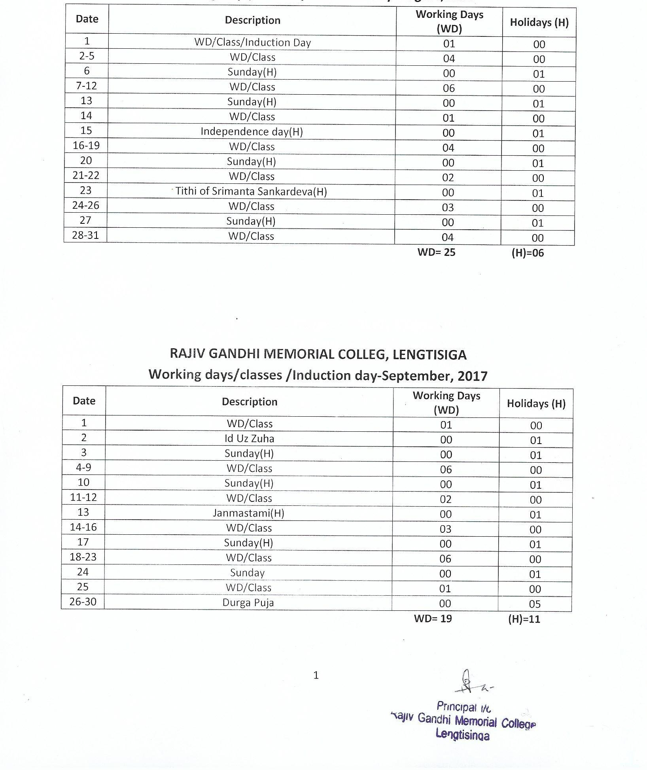

RAJIV GANDHI MEMORIAL COLLEG, LENGTISIGA
Working days/classes /Induction day-October, 2017
Date | Description | Working Days (WD) | Holidays (H)
1-5 | Durga Puj , Lakshmi Puja | 00 | 05
6-7 | WD/Class | 02 | 00
8 | Sunday(H) | 00 | 01
9-14 | WD/Class | 06 | 00
15 | Sunday(H) | 00 | 01
16-17 | WD/Class | 02 | 00
18-20 | Kati Bihu, Kali Puja & Dewali | 00 | 03
21 | WD/Class | 01 | 00
22 | Sunday(H) | 00 | 01
23-28 | WD/Class | 06 | 00
29 | Sunday | 00 | 01
30-31 | WD/Class | 02 | 00
WD= 19 (H)=12

RAJIV GANDHI MEMORIAL COLLEG, LENGTISIGA
Working days/classes /Induction day-November, 2017
Date | Description | Working Days (WD) | Holidays (H)
1-3 | WD/Class | 03 | 00
4 | Birth Day of Guru Nanak | 00 | 01
5 | Sunday(H) | 00 | 01
6-11 | WD/Class | 06 | 00
12 | Sunday(H) | 00 | 01
13-18 | WD/Class | 06 | 00
19 | Sunday (H) | 00 | 01
20-23 | WD/Class | 04 | 00
24 | Lachit Diwas | 00 | 01
25 | WD/Class | 01 | 00
26 | Sunday (H) | 00 | 01
27-30 | WD/Class | 04 | 00
WD= 24 (H)= 06
*Odd Semester Examination to be held in the month of November and December.

RAJIV GANDHI MEMORIAL COLLEG, LENGTISIGA
Working days/classes /Induction day-Decmber, 2017
Date | Description | Working Days (WD) | Holidays (H)
1 | WD/Class/Induction Day | 01 | 00
2 | Axom Diwas | 00 | 01
3 | Sunday(H) | 00 | 01
4-9 | WD/Class | 06 | 00
10 | Sunday(H) | 00 | 01
11-16 | WD/Class | 06 | 00
17 | Sunday(H) | 00 | 01
18-23 | WD/Class | 06 | 00
24 | Sunday(H) | 00 | 01
25 | Chrirstmas Day | 00 | 01
26-31 | Winter Break | 00 | 06
WD = 19 (H) =12

RAJIV GANDHI MEMORIAL COLLEG, LENGTISIGA
Working days/classes /Induction day-January, 2018
Date | Description | Working Days (WD) | Holidays (H)
1-17 | Semester Break and Magh Bihu (H) | 00 | 17
18-20 | WD/Class | 03 | 00
21 | Sunday(H) | 00 | 01
22 | Saraswati Puja (H) | 00 | 01
23-25 | WD/Class | 03 | 00
26 | Republic Day | 00 | 01
27 | WD/Class | 01 | 00
28 | Sunday(H) | 00 | 01
29-31 | WD/Class | 03 | 00
WD= 10 (H)=21

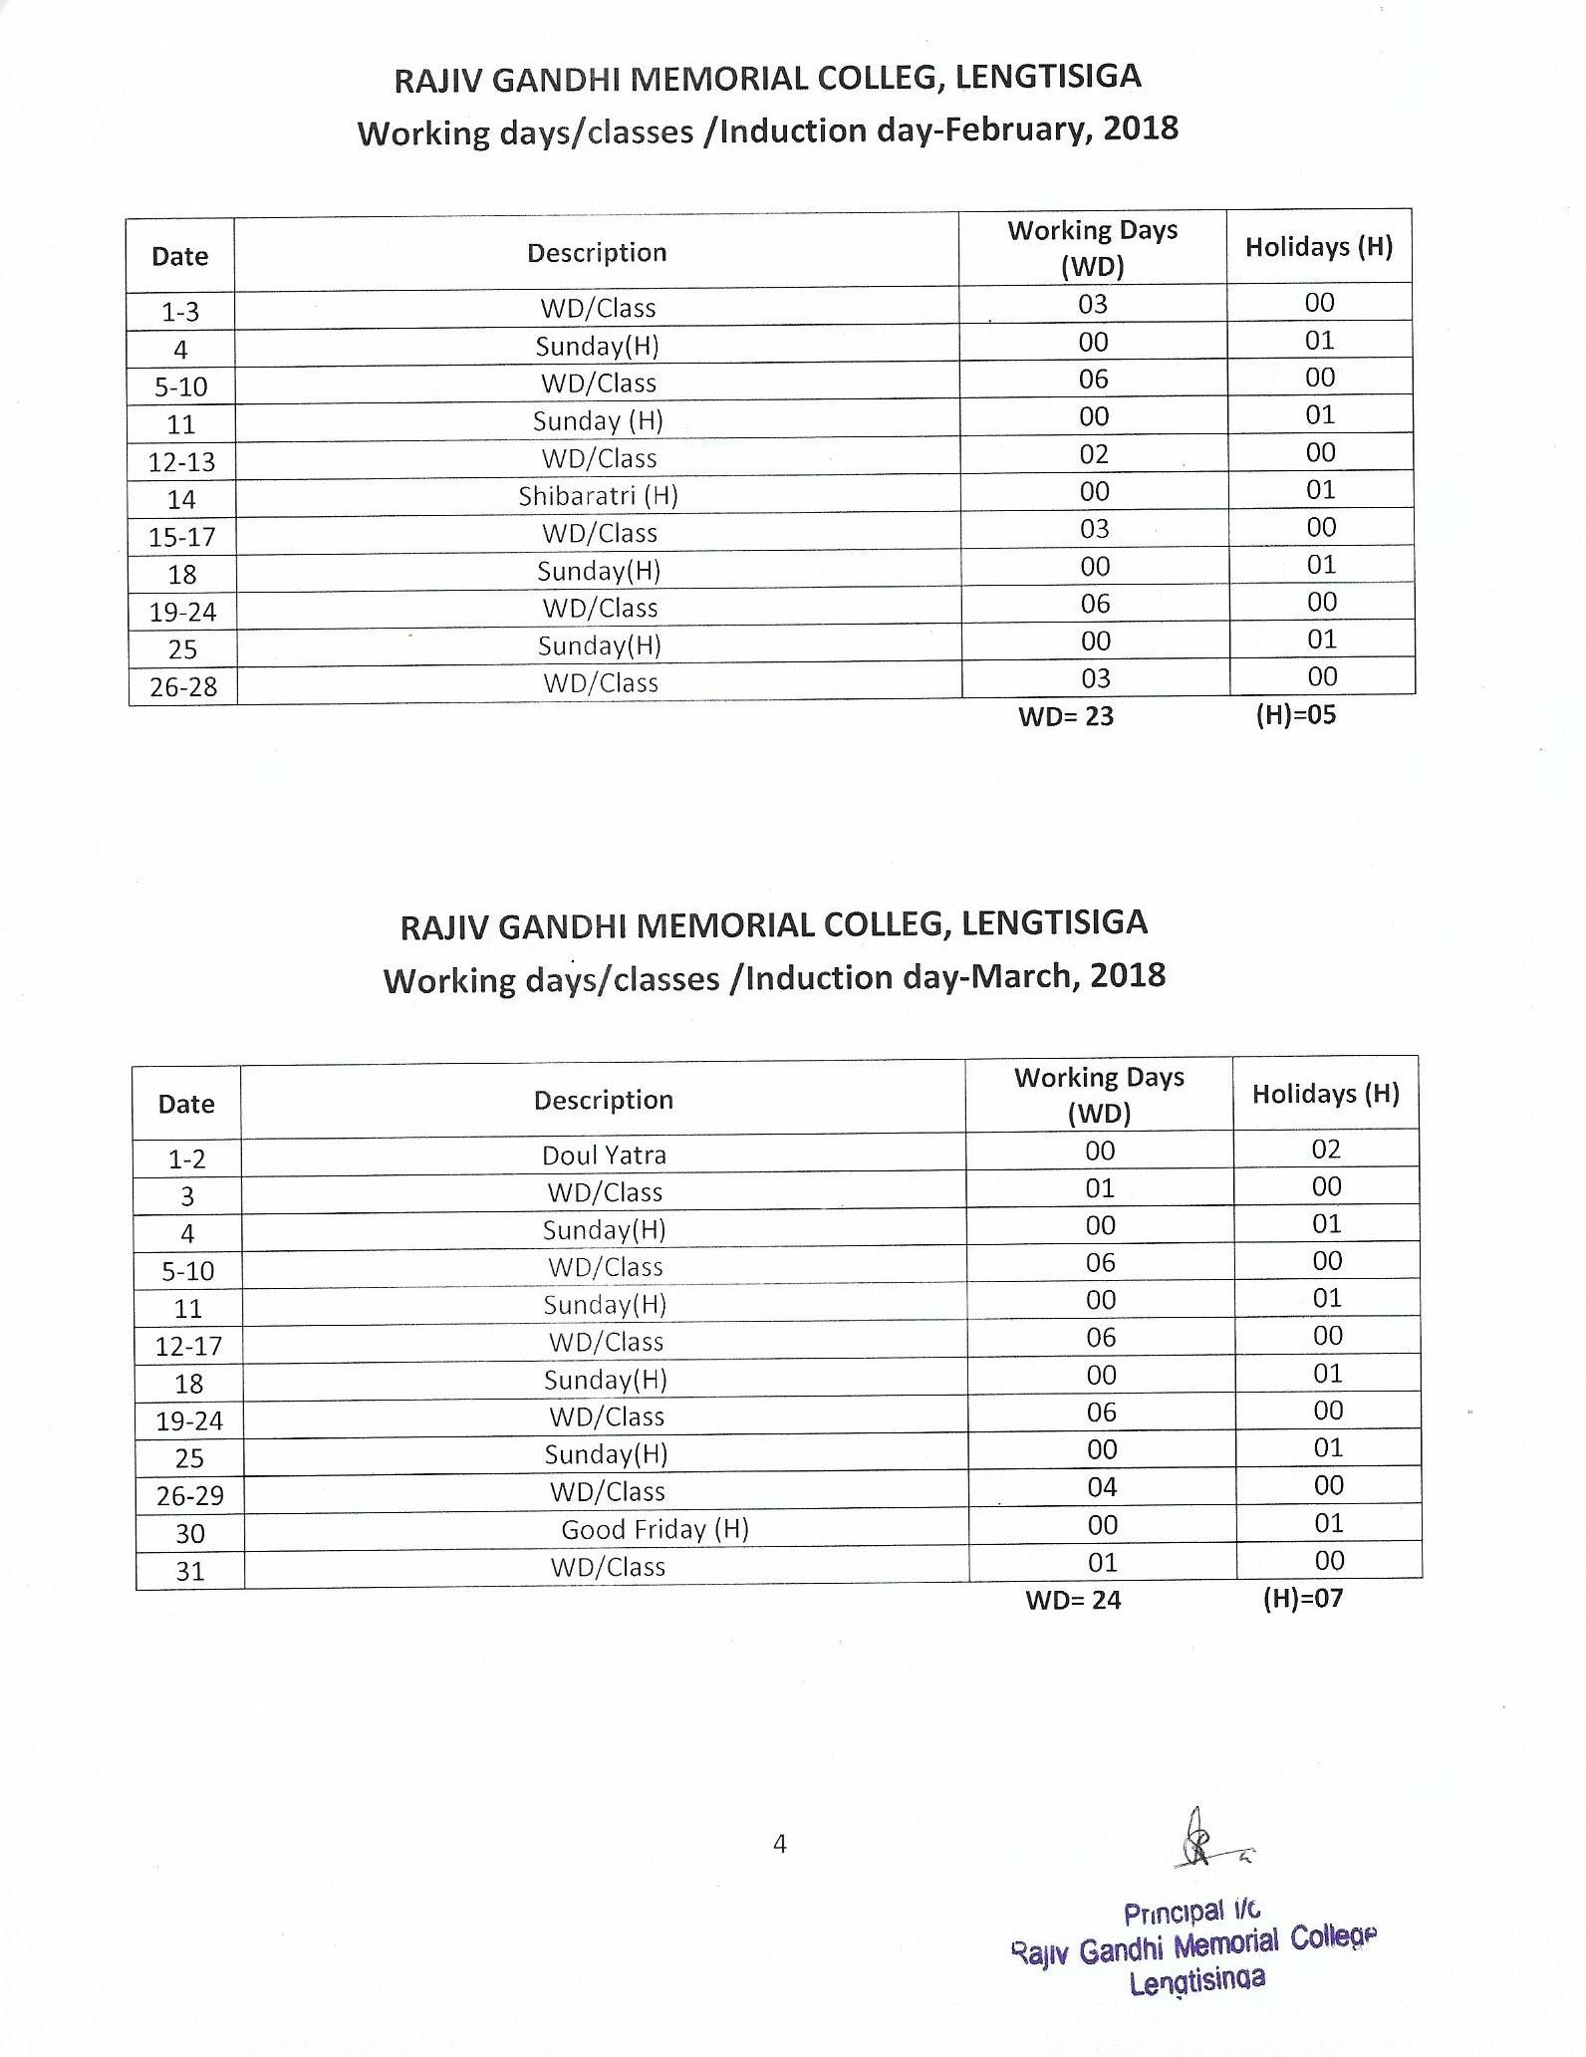
RAJIV GANDHI MEMORIAL COLLEG, LENGTISIGA
Working days/classes /Induction day-April, 2018
Date | Description | Working Days (WD) | Holidays (H)
1 | Sunday | 00 | 01
2-7 | WD/Class | 06 | 00
8 | Sunday(H) | 00 | 01
9-13 | WD/Class | 05 | 00
14-16 | Bohag Bihu (H) | 03 | 00
17-21 | WD/Class | 05 | 00
22 | Sunday(H) | 00 | 01
23-28 | WD/Class | 06 | 00
29 | Sunday(H) | 00 | 01
30 | Buddha Purnima (H) | 00 | 01
WD= 25 (H)= 05

RAJIV GANDHI MEMORIAL COLLEG, LENGTISIGA
Working days/classes /Induction day-May, 2018
Date | Description | Working Days (WD) | Holidays (H)
1 | May Day (H) | 00 | 01
2-5 | WD/Class | 04 | 00
6 | Sunday(H) | 00 | 01
7-12 | WD/Class | 06 | 00
13 | Sunday(H) | 00 | 01
14-19 | WD/Class | 06 | 00
20 | Sunday(H) | 00 | 01
21-26 | WD/Class | 06 | 00
27 | Sunday(H) | 00 | 01
28-31 | WD/Class | 04 | 00
WD= 26 (H)= 05

RAJIV GANDHI MEMORIAL COLLEG, LENGTISIGA
Working days/classes /Induction day-June, 2018
Date | Description | Working Days (WD) | Holidays (H)
1-2 | WD/Class | 02 | 00
3 | Sunday(H) | 00 | 01
4-9 | WD/Class | 06 | 00
10 | Sunday(H) | 00 | 01
11-14 | WD/Class | 04 | 00
15-16 | Id Ul Fitre | 00 | 02
17 | Sunday(H) | 00 | 01
18-23 | WD/Class | 06 | 00
24 | Sunday(H) | 00 | 01
25-30 | WD/Class | 06 | 00
WD= 24 (H)= 06
Note:
- Summer Vacation from-01-07-2018 to 31-07-2018
- Subject to revision as per G. U. academic calendar 2017-2018
- Holidays mention in the calendar may be changed subject to Govt. and University notifications.
- Dates of B. A. Semester Examinations will be notified by G.U.
- Total Working Days= 238
- Total Holidays= 96
** WD stands for Working Days.* (H) for Holidays

